# Adding New Columns

This document includes the question, the solution, and a breakdown of the code provided in the screenshot.

## Uploaded Screenshot

Below is the screenshot of the task:

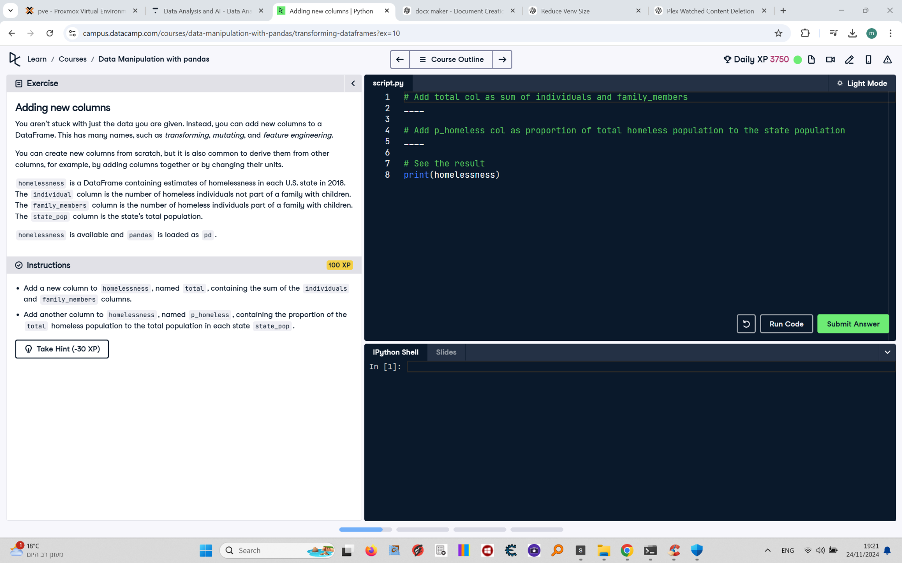

## Question

Add a new column to `homelessness`, named `total`, containing the sum of the `individuals` and `family_members` columns. Add another column to `homelessness`, named `p_homeless`, containing the proportion of the `total` homeless population to the total population in each state, `state_pop`. View the printed result.

## Answer

# Add total column as sum of individuals and family_members  
homelessness['total'] = homelessness['individuals'] + homelessness['family_members']  
  
# Add p_homeless column as proportion of total homeless population to state population  
homelessness['p_homeless'] = homelessness['total'] / homelessness['state_pop']  
  
# See the result  
print(homelessness)

## Code Explanation

# Explanation of the code:

1. `homelessness['total'] = homelessness['individuals'] + homelessness['family_members']`: Adds a new column named `total` to the `homelessness` DataFrame. This column is calculated by summing the values in the `individuals` and `family_members` columns.

2. `homelessness['p_homeless'] = homelessness['total'] / homelessness['state_pop']`: Adds a new column named `p_homeless` to the `homelessness` DataFrame. This column is calculated as the proportion of the `total` homeless population to the state's total population (`state_pop`).

3. `print(homelessness)`: Prints the updated DataFrame to verify that the new columns have been added and calculated correctly.